LAB ASSIGNMENT 1

HALL TICKET NO: 2303A52380

BATCH 14 TASK 1

Write a function to calculate compound interest, staring with only the function name . then add a docstring, then input -output example.

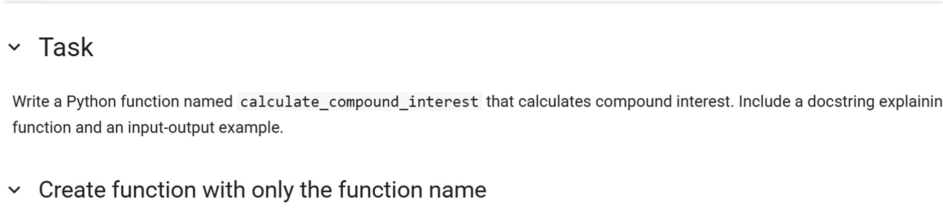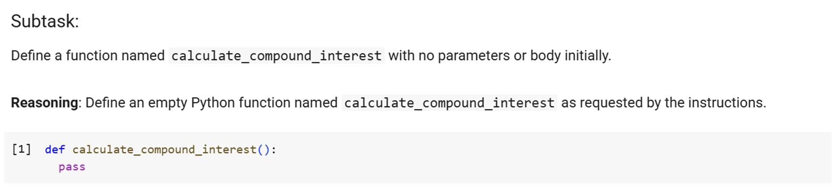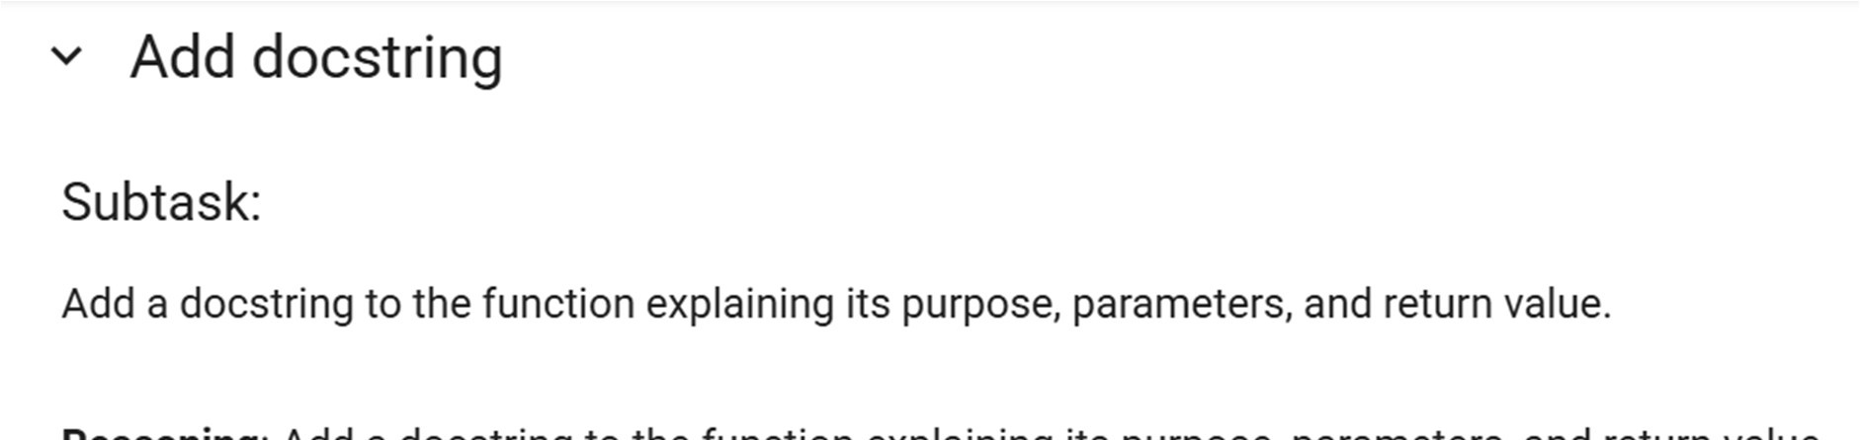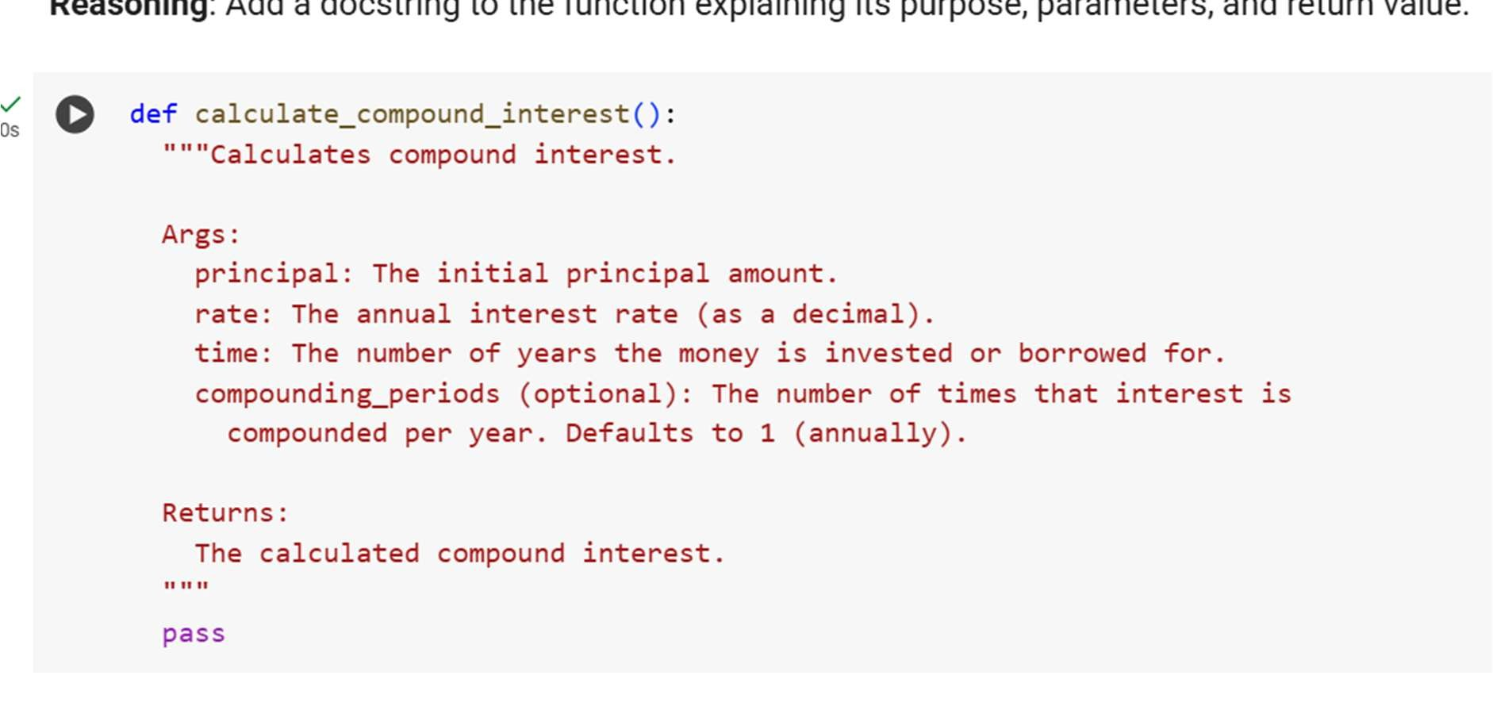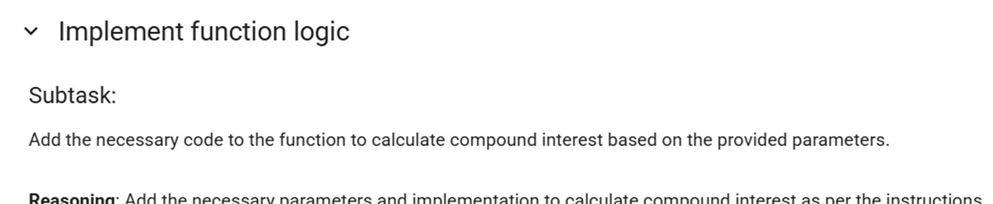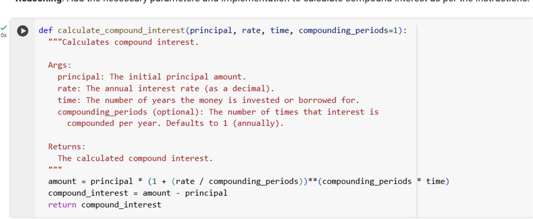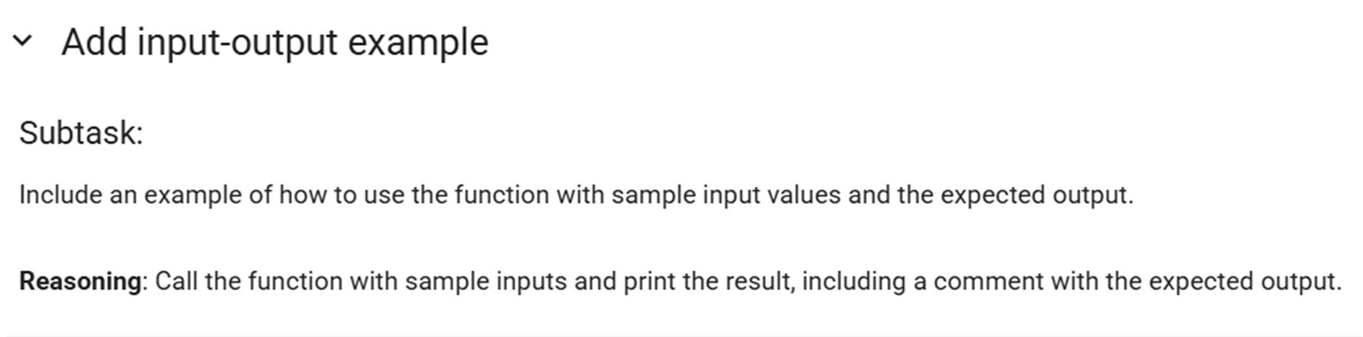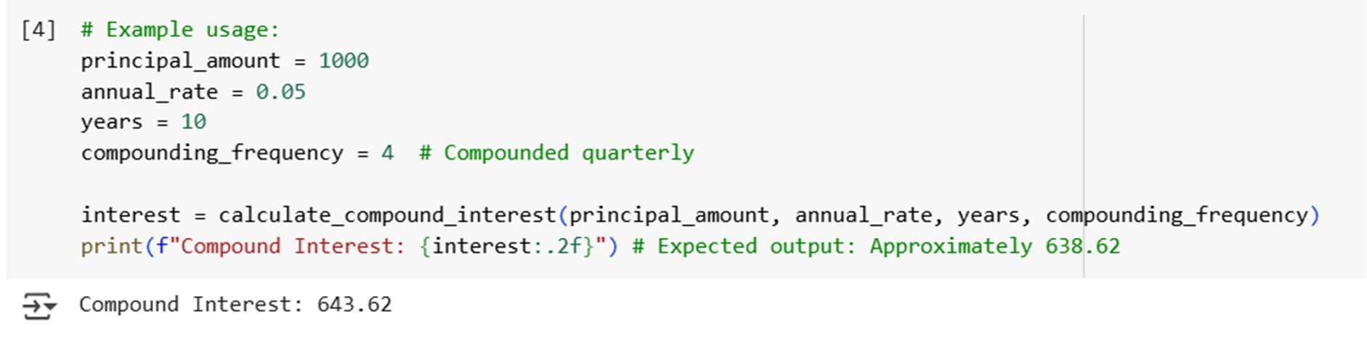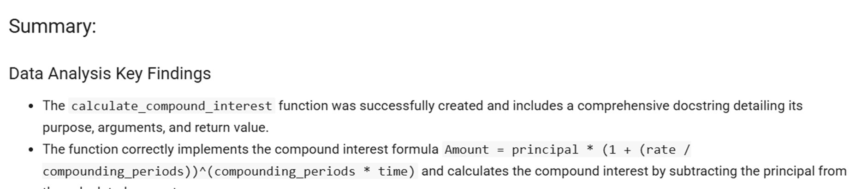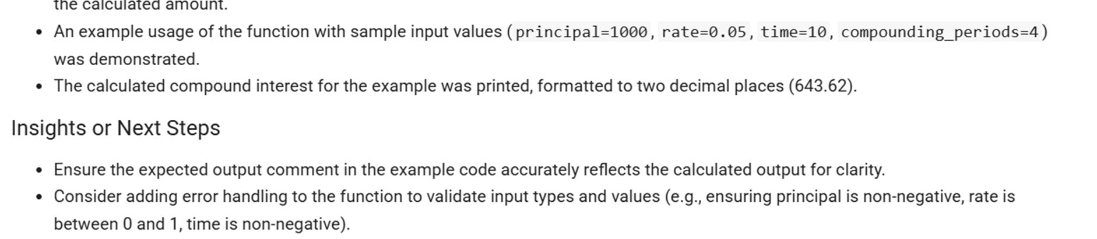

# TASK 2

Write a Python function to calculate the average, median, and mode of a list of numbers.

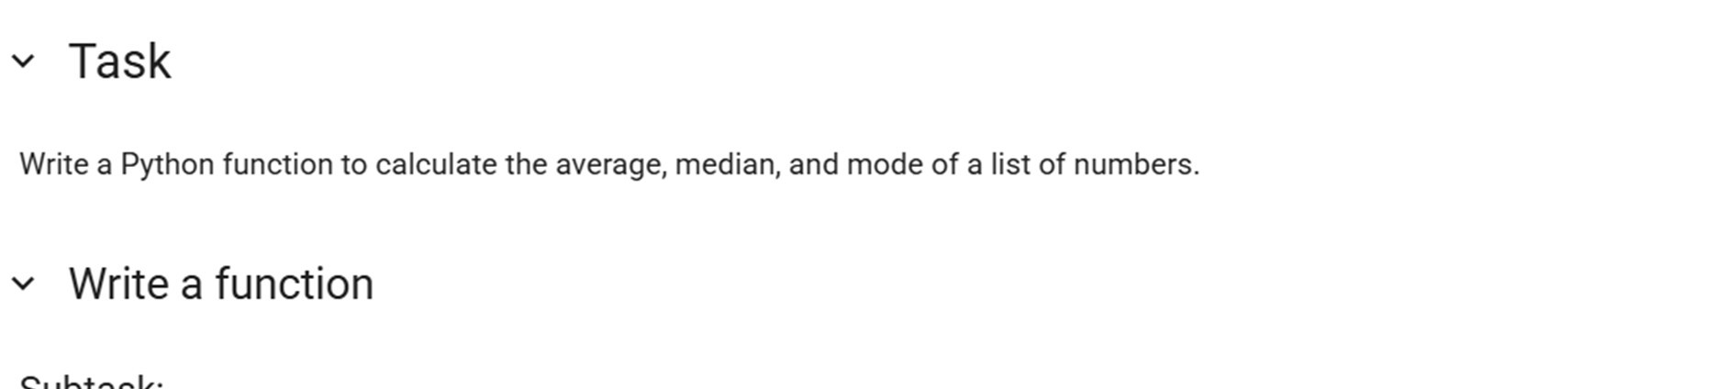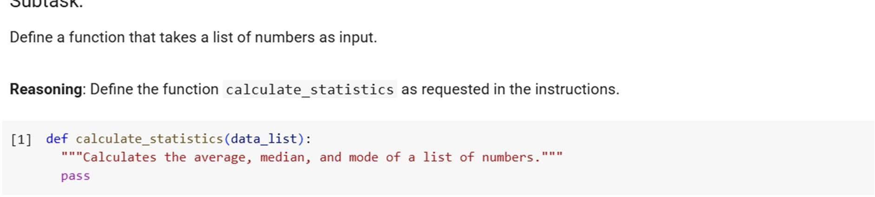

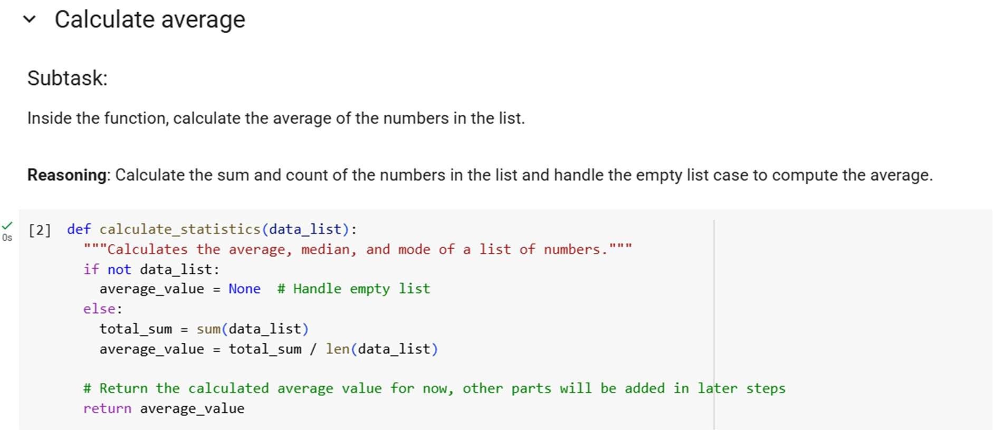

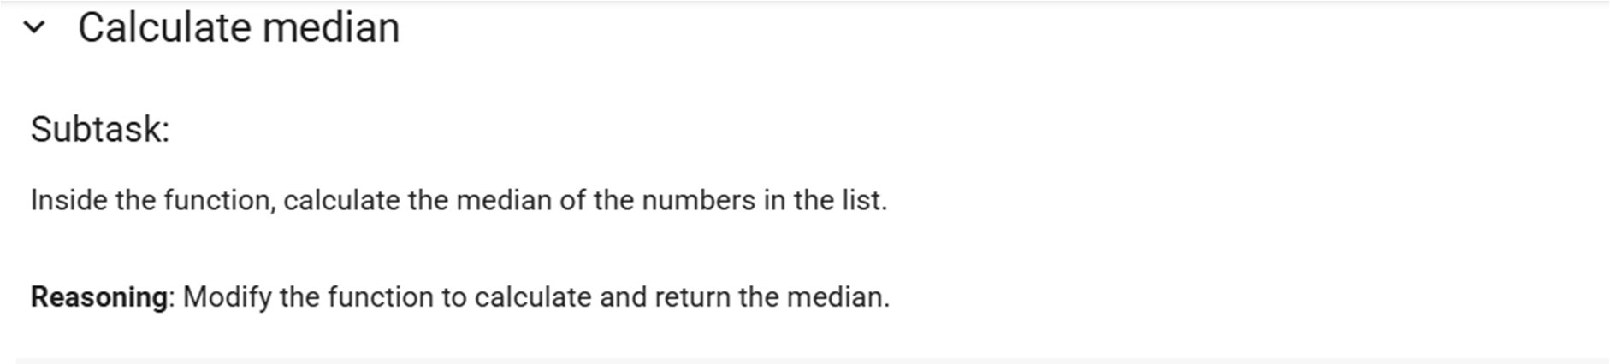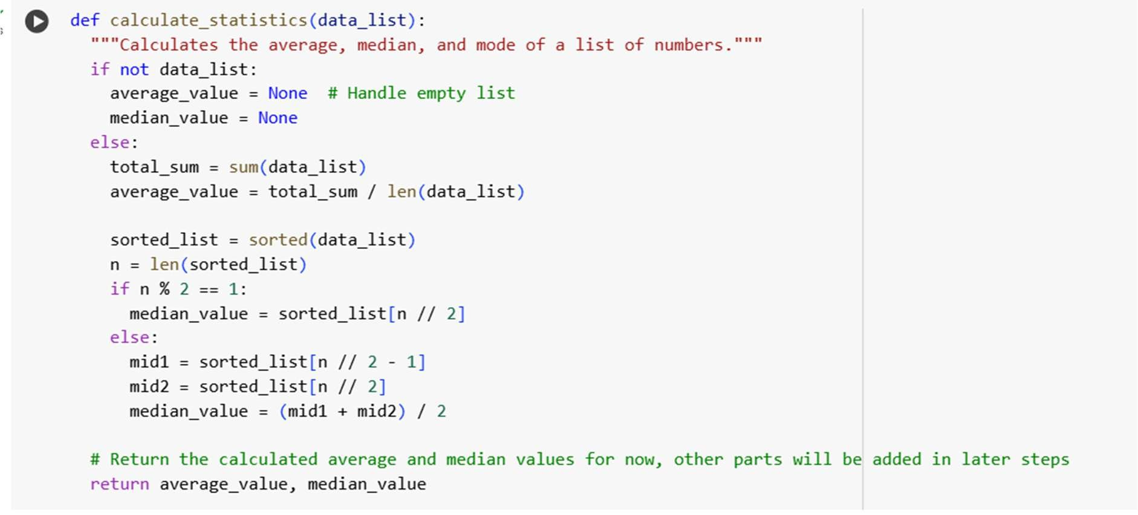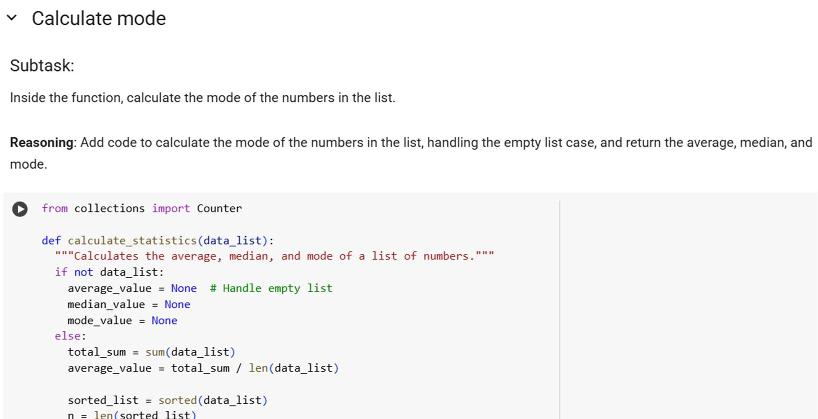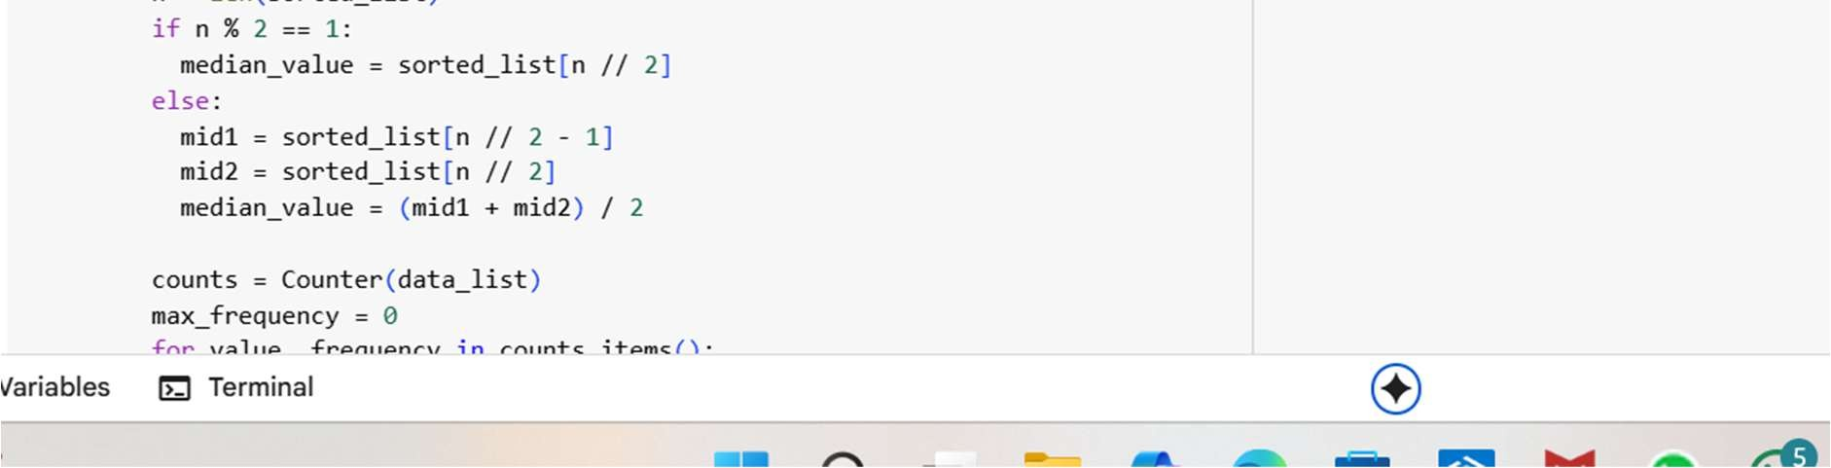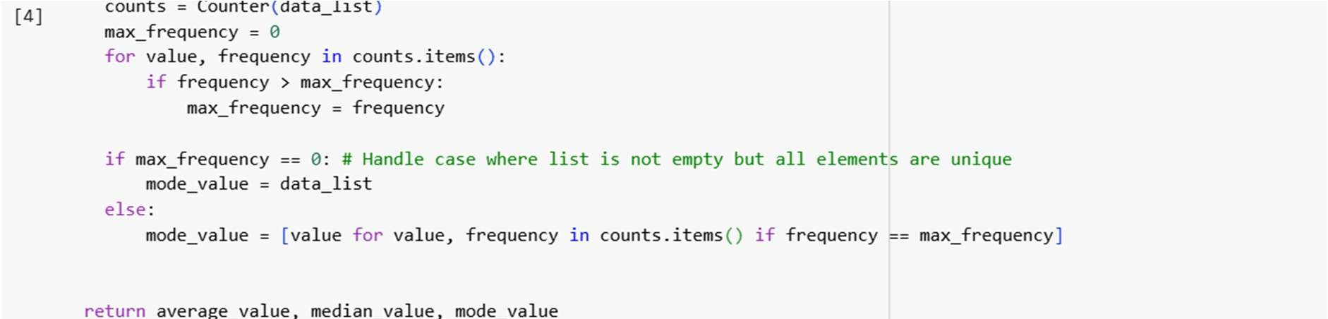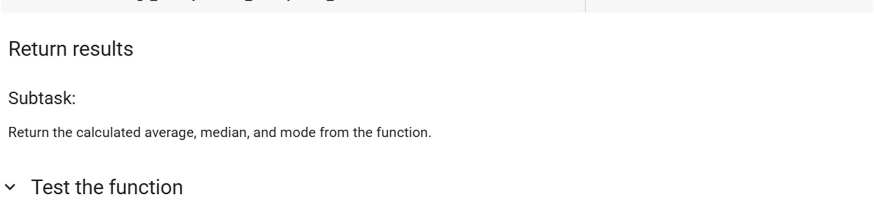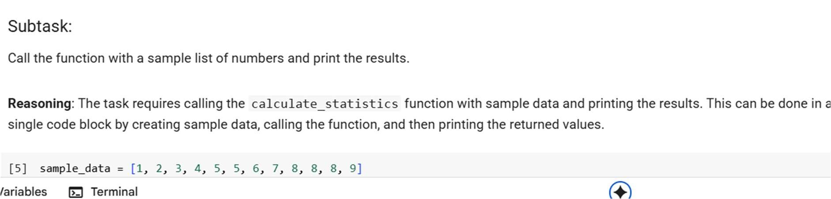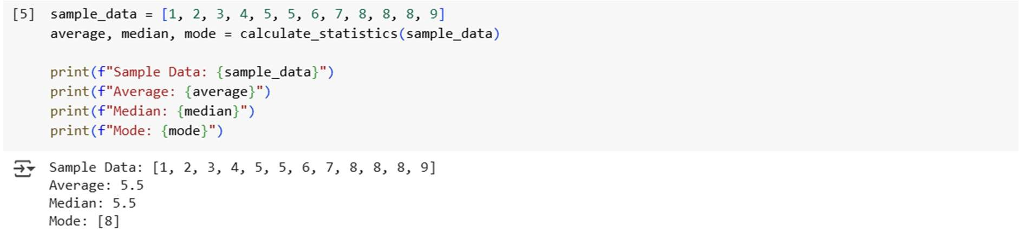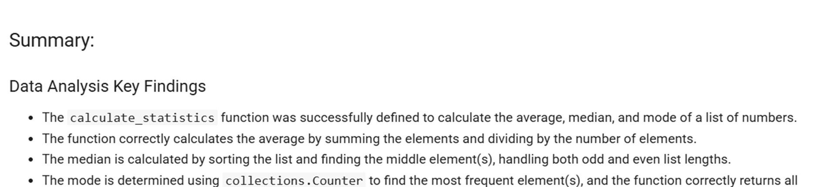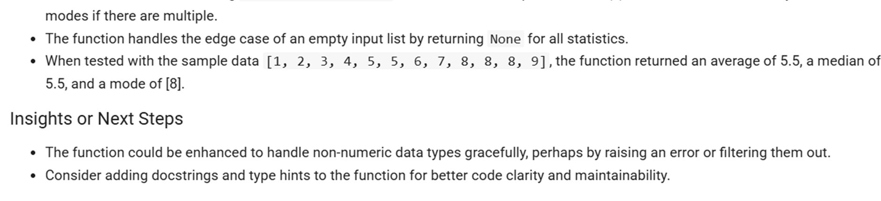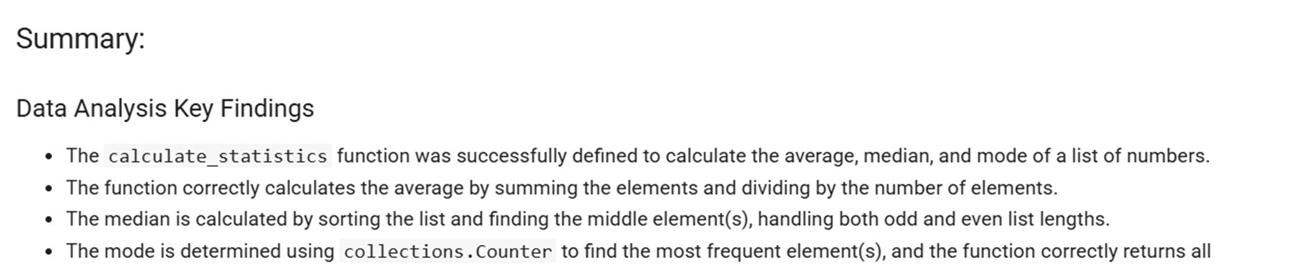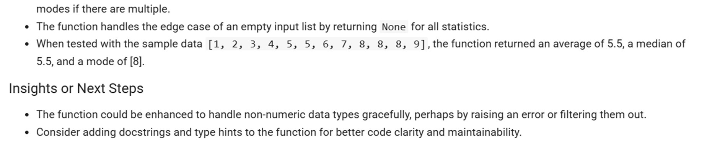

## TASK 3

Provide multiple examples of input-output to the AI for conert_to_binary(num) function. Observe how AI uses few-shot prompting to generalize.

